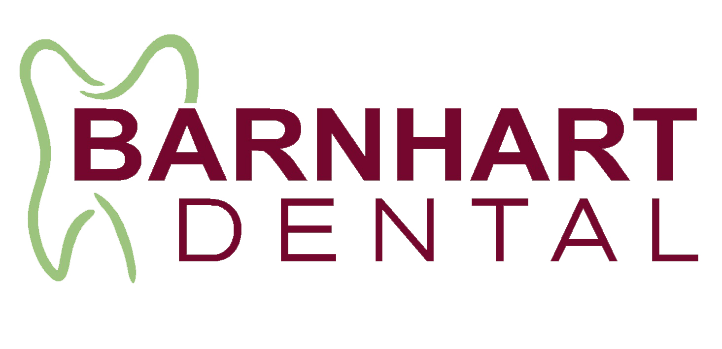 | Barnhart Dental / Show Me Sleep  New Patient Form  Contact & Insurance | 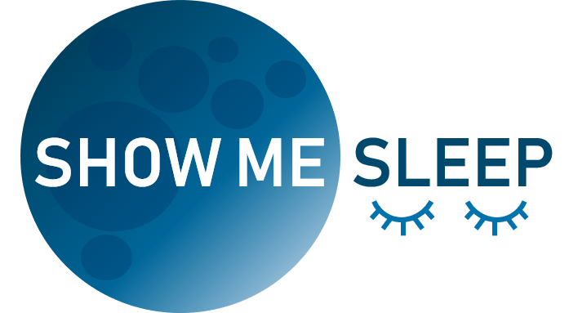
Patient Information
Mr./Ms./Mrs./Dr. First Name: _______________________ Last Name: __________________________ MI: ___
Spouse or Parent/Guardian (if minor) Name: ______________________________________________________
Date of Birth (M/D/Y): ____ /____ /______ Gender: □M □ F Social Security Number (SSN): ___________________
Home Phone (____) _____________ Cell Phone (____) ______________ Work Phone (____) ________________
The best time to contact me is: □ Morning □ Mid-Day □ Evening on □ Home phone □ Cell phone □ Work phone
Email Address______________________________ Would you like to receive our e-newsletter? □ Yes □ No
Address: _____________________________________City: __________________ State: _____ Zip: ____________
Height: Feet_____ Inches_____ Weight (lbs.): ______ Marital Status: □ Married □ Single □ Life Partner □ Minor
Emergency Contact: ___________________________ Relationship: _______________ Phone___________________

- PLEASE CHECK THIS BOX IF WE MAY USE YOUR NAME AND/OR LIKENESS FOR ANY MARKETING SUCH AS OUR WEBSITE, FACEBOOK, ECT….
WHO MAY WE THANK FOR REFERRING YOU TO OUR OFFICE? :______________________________________

- IF OTHER CHOOSE FROM THE FOLLOWING:

□ INSURANCE CO. □ FACEBOOK □ PUBLICATION □ RADIO AD □ GOOGLE SEARCH
□ PHONE BOOK □ PHYSICIAN □ MAILING □ OFFICE SIGN □ OTHER ___________
Employer Information
Employer: ___________________________________Phone: (____) ______________Fax: (____) ______________
Address: ____________________________________City____________________State: ______Zip: ___________

PLEASE PRESENT YOUR DENTAL AND MEDICAL INSURANCE CARDS TO THE FRONT DESK FOR THEM TO MAKE COPIES!

I HEREBY ACCEPT AND ACKNOWLEDGE THAT I AM FINANCIALLY RESPONSIBLE FOR THE PAYMENT OF ALL CHARGES REGARDLESS OF INSURANCE. IN THE EVENT A BALANCE IS NOT PAID IN FULL, I HEREBY ACKNOWLEDGE THAT I AM FURTHER RESPONSIBLE FOR COLLECTION COSTS, COURT COSTS, AND ATTORNEY FEES IN COLLECTING THE DEBT. RETURNED CHECKS ARE SUBJECT TO A SERVICE FEE, SUBJECT TO CHANGE. I UNDERSTAND THE NO-SHOW/LATE CANCEL POLICY.

______________________________________________________________________________________________
Patient Signature Printed ` Date

______________________________________________________________________________________________
Patient/Authorized signature Relationship to patient:
Barnhart Dental / Show Me Sleep
New Patient Form
Insurance Continued
MEDICAL HISTORY:

Family History:
(Please circle the following)

Have genetic members of your family had:
Heart Disease? YES NO High Blood Pressure? YES NO Diabetes? YES NO
Have genetic members of your family been diagnosed or treated for a sleep disorder? YES NO
How often do you consume alcohol within 2-3 hours of bedtime? Daily Occasionally Rarely/Never
How often do you take sedatives within 2-3 hours of bedtime? Daily Occasionally Rarely/Never
How often do you consume caffeine 2-3 hours of bedtime? Daily Occasionally Rarely/Never
Do you drink Coffee or Tea? YES NO If YES: How many cups in a day? ________
Do you use Tobacco? YES NO If YES: Which? Smoking ___ Dipping ____

*It is important that we know your medical history. Many things have a direct bearing on your sleep health.
Information you give us is strictly confidential and will not be released to anyone without your permission.

DO YOU HAVE, OR HAVE YOU EVER HAD, ANY OF THE FOLLOWING? PLEASE √ (check) YOUR ANSWER

◻ Abrupt awakenings  ◻ Acid Reflex  ◻ Alcoholism  ◻ Allergies to medications  ◻ Anemia  ◻ Arthritis  ◻ Artificial Joint(s)  ◻ Asthma  ◻ Atrial Fibrillation  ◻ Auto-immune Disorder  ◻ Blood Disease  ◻ Bone Disease  ◻ Blood Thinners  ◻ Blood Transfusion  ◻ Cancer  ◻ Chest Pain | ◻ Circulatory Problems  ◻ Congestive heart failure  ◻ Convulsions/Seizures  ◻ COPD  ◻ Daytime sleepiness  ◻ Diabetes Type __  ◻ Dry mouth/sore throat  ◻ Excessive Bleeding  ◻ Frequent Headaches  ◻ Glaucoma  ◻ GERD  ◻ Hearing Impaired  ◻ Heart Disease  ◻ Heart Stent  ◻ Heart Surgery  ◻ Heart Valve, Murmur | ◻ Hepatitis Type: _____  ◻ High Blood Pressure  ◻ HIV/AIDS  ◻ Irregular Heartbeat  ◻ Kidney Disease  ◻ Latex Allergy  ◻ Low Blood Pressure  ◻ Liver Disease  ◻ Lupus  ◻ Lung Disease  ◻ Mitral Valve Prolapse  ◻ Neck & Back Problems  ◻ Nervous Problems/Disorders  ◻ Pacemaker  ◻ Post-Medicate  ◻ Pre-Medicate | ◻ Psychiatric Problems  ◻ Radiation Treatment  ◻ Respiratory Problems  ◻ Restless leg syndrome  ◻ Rheumatic Fever  ◻ Seizures/Fainting spells  ◻ Seasonal Allergies  ◻ Sinus Problems  ◻ Sleep Apnea  ◻ Snoring  ◻ Stomach Ulcers  ◻ Stroke  ◻ Thyroid Disease  ◻ Tuberculosis  ◻ Use a CPAP  ◻ Withhold Epinephrine

Barnhart Dental / Show Me Sleep
New Patient Form
Medical History Continued

PLEASE LIST ALL MEDICATIONS, INCLUDING VITAMINS AND OVER THE COUNTER MEDICATIONS: Including Aspirin or any blood thinners

_________________________________________________________________________________________________________________________________________________________________________________________________________________________________

ALLERGENS: Please list everything you are allergic to (example: aspirin, latex, penicillin, etc...)
______________________________________________________________________________________________________________________________________________________________________________________
PRE-MEDICATION- Have you been told that you should receive pre-medication before a dental procedure?
Please circle: YES NO
IF YES, what mediation(s) and why do you require it? _______________________________________
Medical Contacts
BARNHART DENTAL/SHOW ME SLEEP coordinates treatment with your other medical providers to ensure maximum benefits to you. Where applicable, please list your other medical providers.
PRIMARY CARE DOCTOR: ________________________________ Phone: __________________________
ENT: __________________________________________________ Phone: ___________________________
SLEEP DOCTOR: _______________________________________ Phone: ___________________________
DENTIST: ______________________________________________ Phone: ___________________________
OTHER MD: ____________________________________________ Phone: ___________________________

I UNDERSTAND THE INFORMATION I HAVE GIVEN IS CORRECT AND I TAKE RESPONSIBILITY OF INFORMING THIS OFFICE OF ANY CHANGES INCLUDING THOSE RELATED TO MY HEALTH.

___________________________________________________________________________________________
Patient Signature Printed Date

___________________________________________________________________________________________
Patient/Authorized signature Relationship to patient

Barnhart Dental / Show Me Sleep
New Patient Form
HIPAA Consent

Patient Name: _______________________________________________ DOB: ___/___/____

Purpose of Consent: By signing this form, you will consent to our use and disclosure of your protected health information to carry out treatment, payment activities, and healthcare operations.

Notice of Privacy Practices: You have the right to read our Notice of Privacy Practice before you decide whether to sign this Consent. Our notice provides a description of our treatment, payment activities, and healthcare operations. It also describes the uses and disclosures we may make of your protected health information, and of other important matters about your protected health information. A copy of our Notice accompanies this Consent.
We reserve the right to change our privacy practices as described in our Notice of Privacy Practices. If we change our privacy practices, we will issue a revised Notice of Privacy Practices, which will contain the changes. Those changes may apply to any of your protected health information that we may maintain. In general, the HIPAA privacy rule gives individuals the right to request on uses and disclosures of their protected health information (PHI) the individual is also provided the right to request confidential communication.

Right to Revoke: You will have the right to revoke this Consent at any time by giving us written notice of your revocation submitted to Barnhart Dental/ Show Me Sleep. Please understand that revocations of this Consent will not affect any action we took in reliance on this Consent before we received your revocation, and that we may decline to treat you or to continue treating you if you revoke this Consent.

Acknowledgement of Receipt of Notice of Privacy Practices
I agree to allow BARNHART DENTAL/SHOW ME SLEEP to contact me in the following methods regarding my private health information, evaluation and treatment. I authorize BARNHART DENTAL/SHOW ME SLEEP to leave messages for me when I am unavailable.
METHOD NUMBER
YES NO VOICE ON HOME PHONE OR CELL PHONE (___) ________________________
YES NO WORK PHONE (___) ________________________
YES NO TEXT MESSAGE (___) ________________________
YES NO EMAIL ____________________________

I authorize BARNHART DENTAL/SHOW ME SLEEP and medical staff to discuss my healthcare information (which may include history, diagnosis, labs, test results, treatment and other health information) with the contacts listed below.
I understand that by leaving spaces blank I am indicating my choice to be a “No Information” and I do not want any information released to anyone else.

NAME RELATIONSHIP TO PATIENT PHONE
________________________________________________________________________________________
____________________________________________________________________________________
EMERGENCY CONTACT ONLY - NAME: ____________________________ PHONE: ______________________

I have had full opportunity to read and consider the contents of this Consent form and your Notice of Privacy Practices. I understand that; by signing this Consent for, I am giving my consent to your use and disclosure of my protected health information to carry out treatment payment activities and health care operations.

Signature: ______________________________________________ Date: _______________

If this Consent is signed by a personal representative on behalf of the patient, complete the following.

Personal Representative's Name/ Relationship: _______________________________________

Barnhart Dental / Show Me Sleep
New Patient Form
Written Financial Policy
Thank you for choosing Barnhart Dental. Our primary mission is to deliver the best and most comprehensive dental care available. An important part of the mission is making the cost of optimal care as easy and manageable for our patients as possible by offering several payment options.
Payment Options:
We accept the following:
- Cash, Check, Visa, MasterCard or Discover Card
- Monthly Payment Options¹ from CareCredit or iCare Financial.
- Allow you to pay over time
- No annual fees or pre-payment penalties
Please note:
Barnhart Dental requires payment at the time of the appointment.
For plans requiring multiple appointments, alternative payment arrangements may be provided.
For patients with dental insurance we are happy to work with your carrier to maximize your benefit and directly bill them for reimbursement for your treatment. ² The patient’s estimated portion of payment is due at the time of service.
A fee of $16.00 is charged per half hour slot for patients who cancel appointments without 24-hour notice. A fee of $22.00 is charged per half hour slot for patients who miss appointments without any notice.
Barnhart Dental charges $30 for returned checks.
If you have any questions, please do not hesitate to ask. We are here to help you get the dentistry you want and need.

Patient, Parent or Guardian Signature Date

Patient Name (Please Print)

¹Subject to credit approval

²However, if we do not receive payment from your insurance carrier within 90 days, you will be responsible for payment of your treatment fees and collection of your benefits directly from your insurance carrier.

